**Assignment 3.1**

**Calculate the number of employees corresponding to each skill from the table 'employee' which is loaded in the Demo.**

**Associated Data files**

<https://drive.google.com/file/d/0Bxr27gVaXO5sQWV4UUpOXzNuZDA/view?usp=sharing>

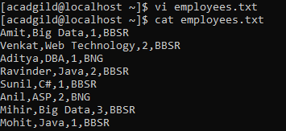

CREATE DATABASE custom;

USE custom;

CREATE EXTERNAL TABLE IF NOT EXISTS EMPLOYEE ( name String, technology String, num int, location String) ROW FORMAT DELIMITED FIELDS TERMINATED BY ‘,’ ;



LOAD DATA LOCAL INPATH ‘/home/acadgild/employees.txt’ INTO TABLE employee;

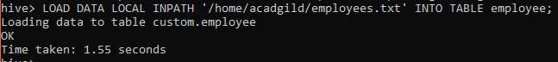

SELECT * FROM EMPLOYEE;

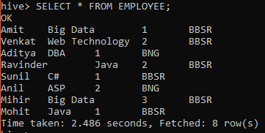

SELECT technology, COUNT(*) FROM EMPLOYEE GROUP BY technology;



